What is kafka and its features?
ref: https://strimzi.io/docs/operators/latest/full/overview
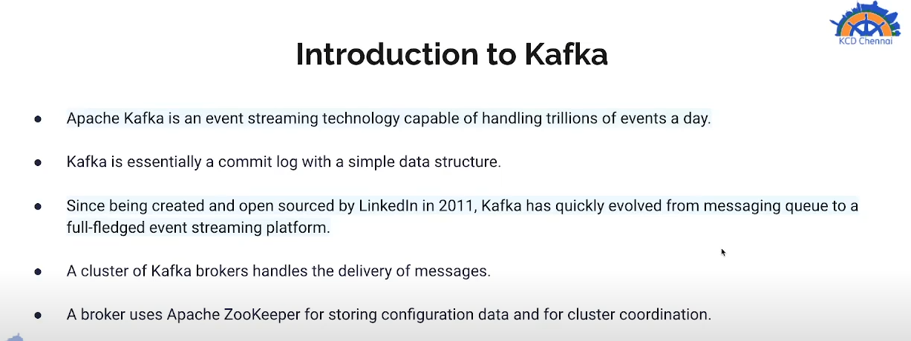

Apache Kafka® Raft (KRaft) is the consensus protocol that was introduced to remove Apache Kafka’s dependency on ZooKeeper™ for metadata management. This greatly simplifies Kafka’s architecture by consolidating responsibility for metadata into Kafka itself, rather than splitting it between two different systems: ZooKeeper and Kafka. KRaft mode is available in the Apache Kafka 3.1 release, though it is not yet ready for use in production environments.

Difficulties
- Scalability: ZooKeeper is not designed to handle a large number of clients or requests. As Kafka clusters grow in size and traffic, ZooKeeper can become a bottleneck and affect the performance and availability of Kafka

his resulted in the development of KRaft mode, which has since been marked as production-ready. As of Kafka 3.5, the ZooKeeper mode is being deprecated, and it will be completely removed from Kafka with the release of Kafka 4.0.
Conclusion
Kafka’s shift from ZooKeeper to KRaft is a major architectural overhaul that simplifies deployment, enhances scalability, and improves performance. KRaft mode eliminates the need for a separate ZooKeeper ensemble, making it easier to deploy and manage Kafka clusters.
KRaft mode is more scalable than ZooKeeper mode, allowing Kafka clusters to handle more traffic and data. KRaft mode is faster than ZooKeeper mode, resulting in lower latency and higher throughput.

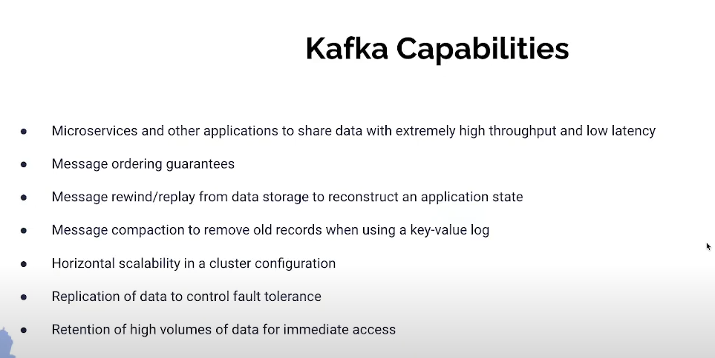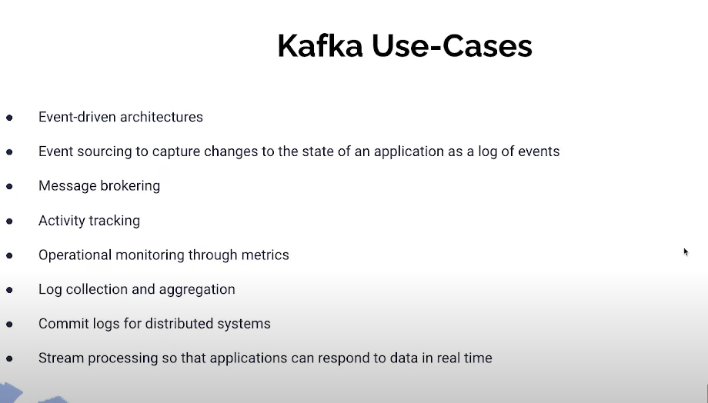

Kafka terminology:

